SUN TRACKING SOLAR PANEL

ABSTRACT

The project uses a solar panel coupled to a stepper motor to track the Sun so that maximum sun light is incident upon the panel at any given time of the day. This is better compared to light sensing method that may not be accurate always for example during cloudy days.
With the impending scarcity of nonrenewable resources, people are considering to use alternate sources of energy. From all other available resources sun energy is the most abundant and it’s comparatively easy to convert it to electrical energy. Use of solar panel to convert sun’s energy to electrical is very popular, but due to transition of the Sun from east to west the fixed solar panel may be able to generate optimum energy. The proposed system solves the problem by an arrangement for the solar panel to track the Sun.
This tracking movement is achieved by coupling a stepper motor to the solar panel such that the panel maintains its face always perpendicular to the Sun to generate maximum energy. This is achieved by using a programmed microcontroller to deliver stepped pulses in periodical time intervals for the stepper motor to rotate the mounted panel as desired. The microcontroller used in this project is from PIC family. The stepper motor is driven by an interfacing IC as the controller is not capable of handling the power requirements of the stepper motor. The project is provided with a dummy solar panel which can be used for demonstration purpose only.
Further the project can be enhanced by using RTC (Real Time Clock) to follow the Sun. This helps in maintaining the required position of the panel even if the power is interrupted for some time.
BLOCK DIAGRAM
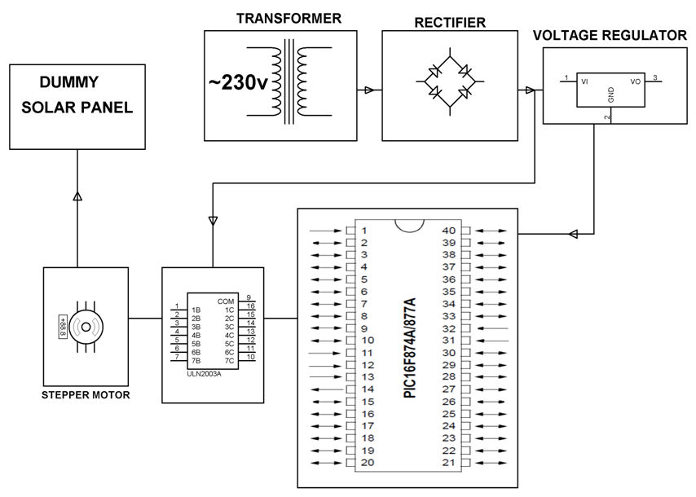
HARDWARE REQUIREMENTS:
PIC series Microcontroller, Dummy Solar Panel, Stepper Motor, Voltage Regulator, Diodes, Relay driver IC, Transformer.
SOFTWARE REQUIREMENTS:
HI-TECH PICC Tool suite
Languages: Embedded C or Assembly

